Architecture Document
Paperforce India LLP Corporate Website
The architecture below is based on the project scope described in the website content draft (Home, About, Products, Reach/Markets, Blog, Contact) and is designed to support a scalable, SEO-focused B2B corporate website.

1. High-Level Architecture
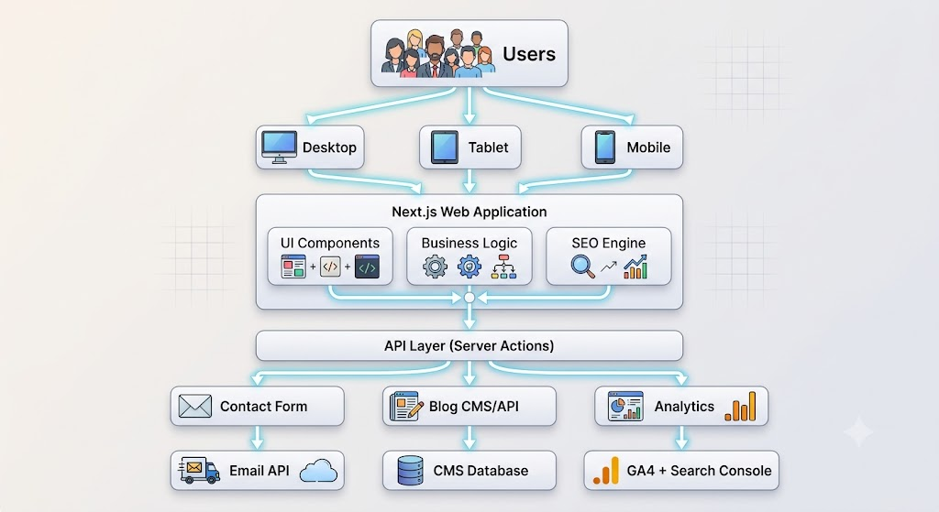

2. User Flow
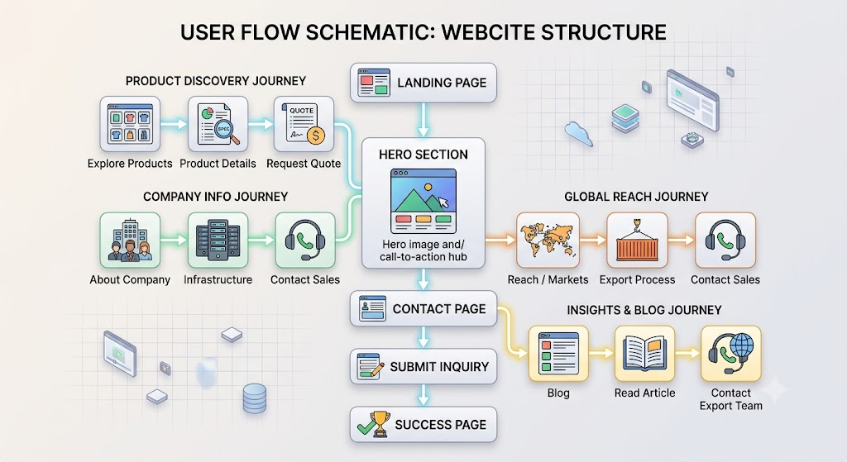

3. Web Application Architecture
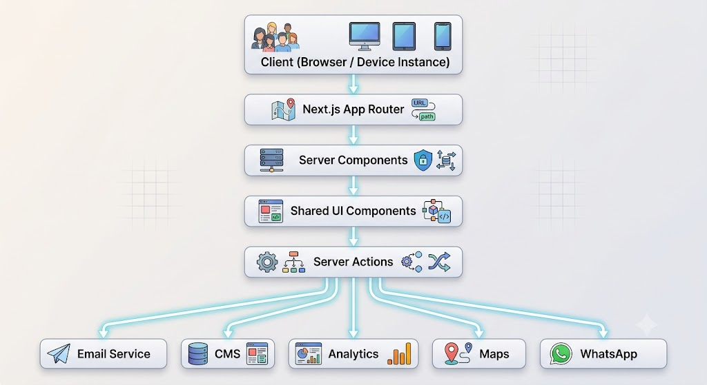

4. Application Layers
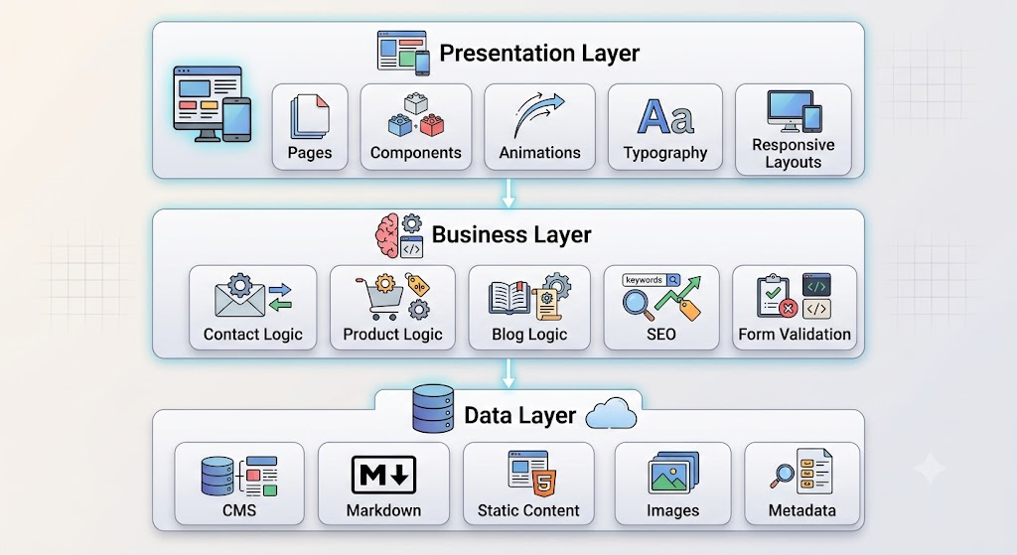

5. Folder Structure
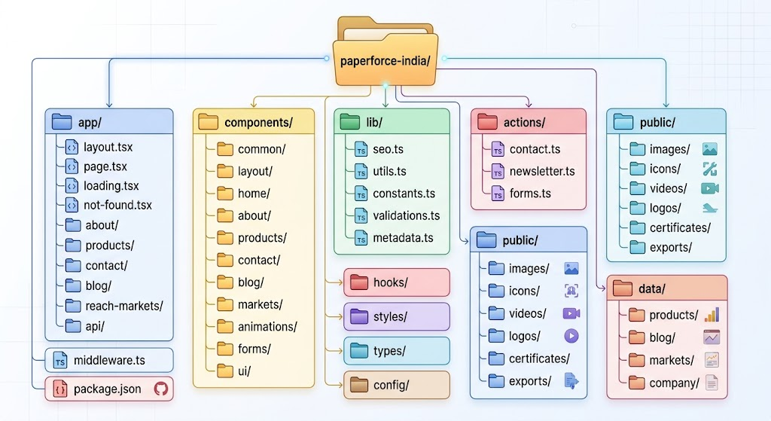
6. Component Architecture
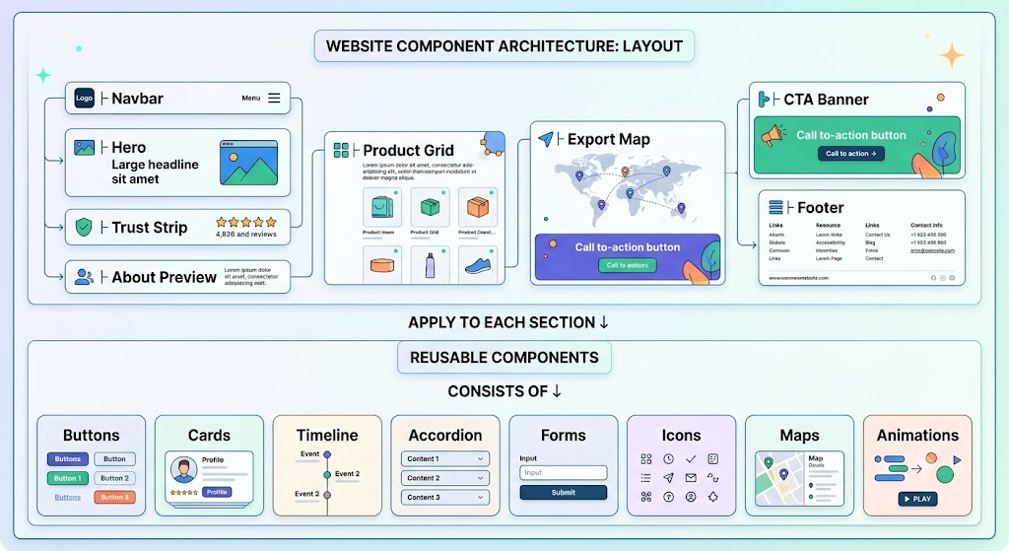

7. Page Architecture
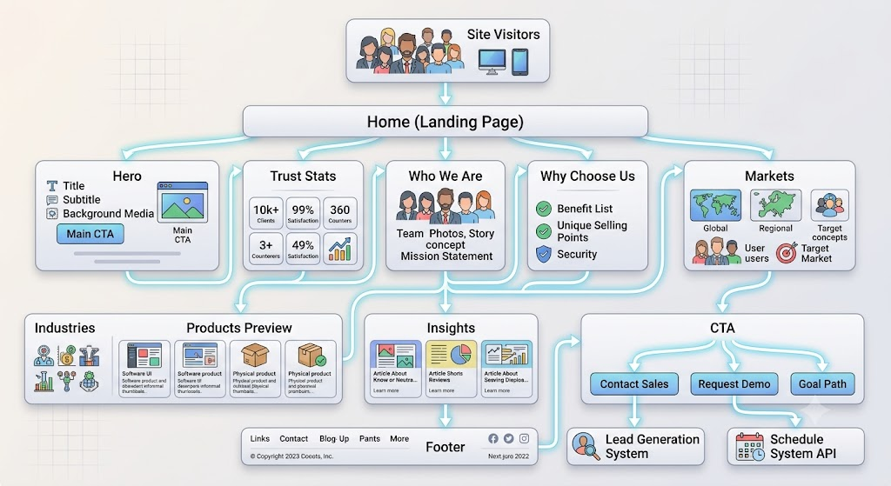

8. Data Flow

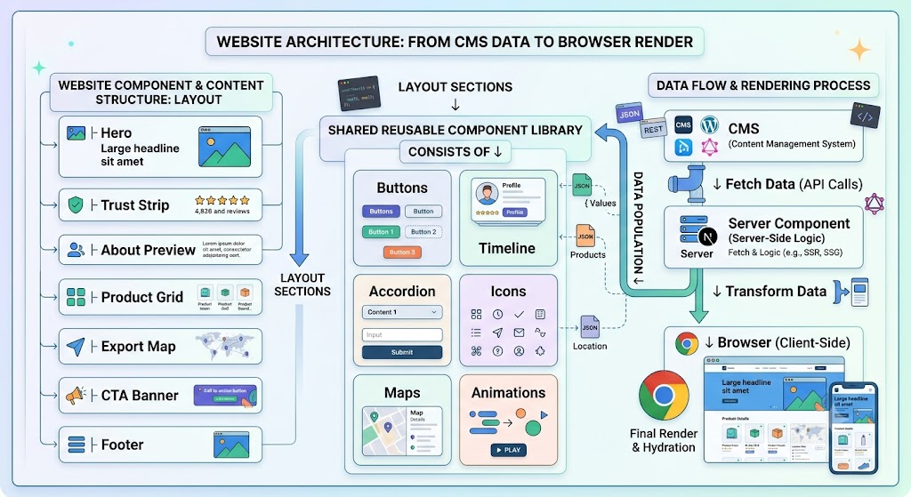

9. Tech Stack
Frontend
- Next.js 15 (App Router)
- React 19
- TypeScript
- Tailwind CSS
- Framer Motion
- GSAP (for advanced scroll storytelling where needed)
- Lenis (smooth scrolling)
- Lucide Icons

Backend
- Next.js Server Actions
- Route Handlers
- Node.js Runtime

CMS
Choose one:
- Sanity CMS (Recommended)
- Contentful
- Strapi
- Payload CMS

Forms
- React Hook Form
- Zod Validation

Email
- Resend
- Nodemailer (SMTP fallback)

Database (Optional)
For future dynamic features:
- PostgreSQL
- Prisma ORM
The current project scope can operate without a database if content is managed through a CMS and form submissions are handled via email.

Storage
- Vercel Blob
- Cloudinary (images/videos)

Maps
- Google Maps Embed

Analytics
- Google Analytics 4
- Google Search Console
- Microsoft Clarity

SEO
- Dynamic Metadata
- Open Graph
- Twitter Cards
- JSON-LD Schema
- XML Sitemap
- Robots.txt

Deployment
- Vercel (Recommended)
- Cloudflare CDN
- GitHub Actions (CI/CD)

10. Security
- HTTPS
- CSP Headers
- Rate Limiting (contact form)
- Bot Protection (Cloudflare Turnstile or reCAPTCHA)
- Input Validation
- Secure Environment Variables
- Secure Email API

11. Performance Strategy
- Server Components by default
- Image optimization with next/image
- Lazy loading for media
- Dynamic imports for heavy sections (e.g., maps, animations)
- Font optimization
- Code splitting
- Incremental Static Regeneration (ISR) for blog content

12. Scalability Roadmap
Phase 1 (MVP)
- Corporate website
- Products
- About
- Markets
- Blog
- Contact
- SEO
- Lead generation
Phase 2
- Product catalogue downloads
- Sample request workflow
- CMS dashboard enhancements
- Multi-language support
Phase 3
- Dealer portal
- Customer login
- CRM integration
- ERP integration
- Shipment tracking
- Analytics dashboard
This architecture is intentionally modular so new pages and business capabilities can be added without restructuring the application. It also aligns with the six-page site structure and B2B lead-generation goals defined in the supplied project documentation

